**VARIABLE SCOPE**

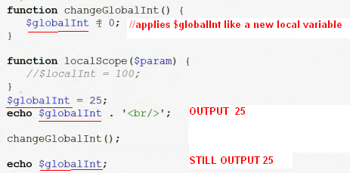

Para utilizer una variable global debe definerse en la function como

**global $globalint = 0;**

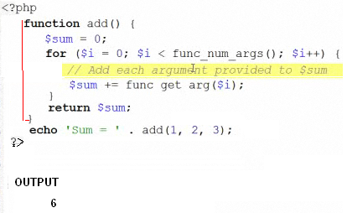

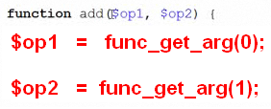

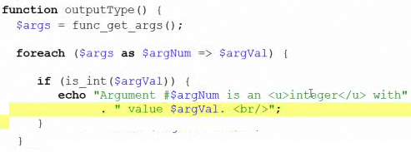

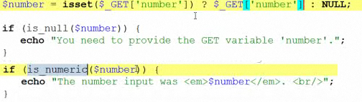

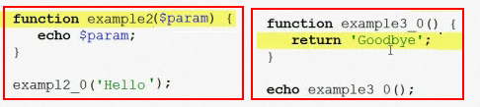

Include a file which is a library

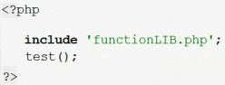

It is an error to include more than once the same file

To avoid the error use **include_once**

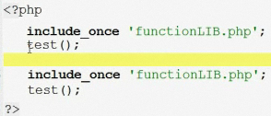

You can use **include_once** or **require_once**

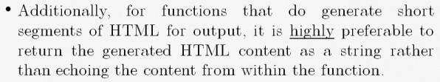

**VERSION 10.0**

**OuputLIB.php**

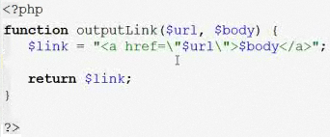



**Change to**

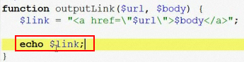



SPECIAL CASES

